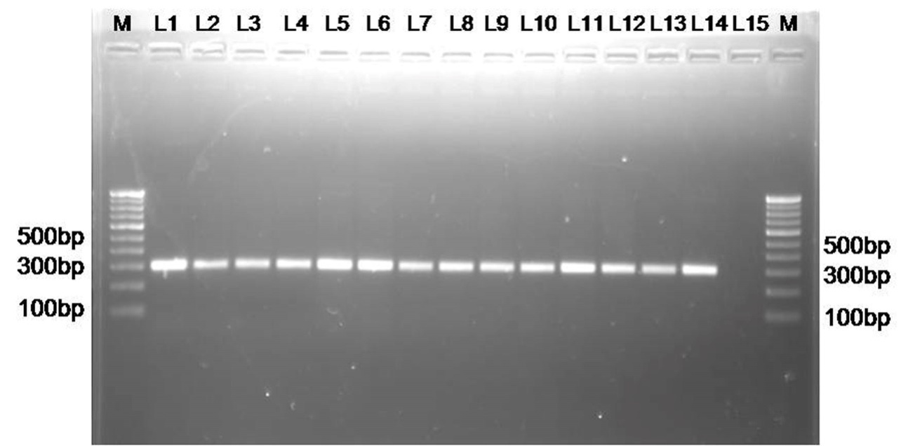

***Supplementary Figure 1****.* 1.5 % agarose gel electrophoresis for *Mycobaterium tuberculosis* complex. Lane M: 100bp ladder; L1: positive control; L2-L4: Lungs; L5: bronchiolar lymph node; L6: parotid lymph node; L7: prescapular lymph node; L8: mandibular lymph node; L9: retropharyngeal lymph node; L10: prescapular lymph node; L11; prefemoral lymph node; L12-L13: liver; L14: udder; L15: Non-template control.

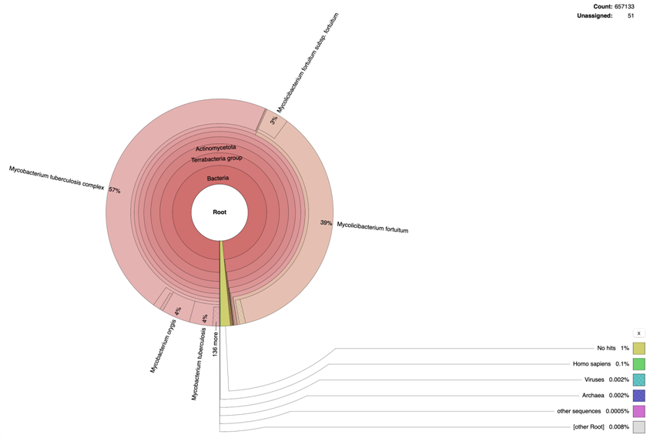

***Supplementary Figure 2:*****Taxonomic distribution of a microbial sample showing predominance of *Mycobacterium* species.**